Extreme Heat Preparedness Campaign

Twitter/X
Saturday, June 21
A stretch of 90°+ days is on the way! Stay cool and safe by visiting City pools.
🏊 War Memorial: indoor swim year-round
☀️ Gold Star Pool opens late June for outdoor fun
Staffed by certified lifeguards.
Details: www.cambridgema.gov/sustainabl...
#CoolSafeCambridge #CambMA

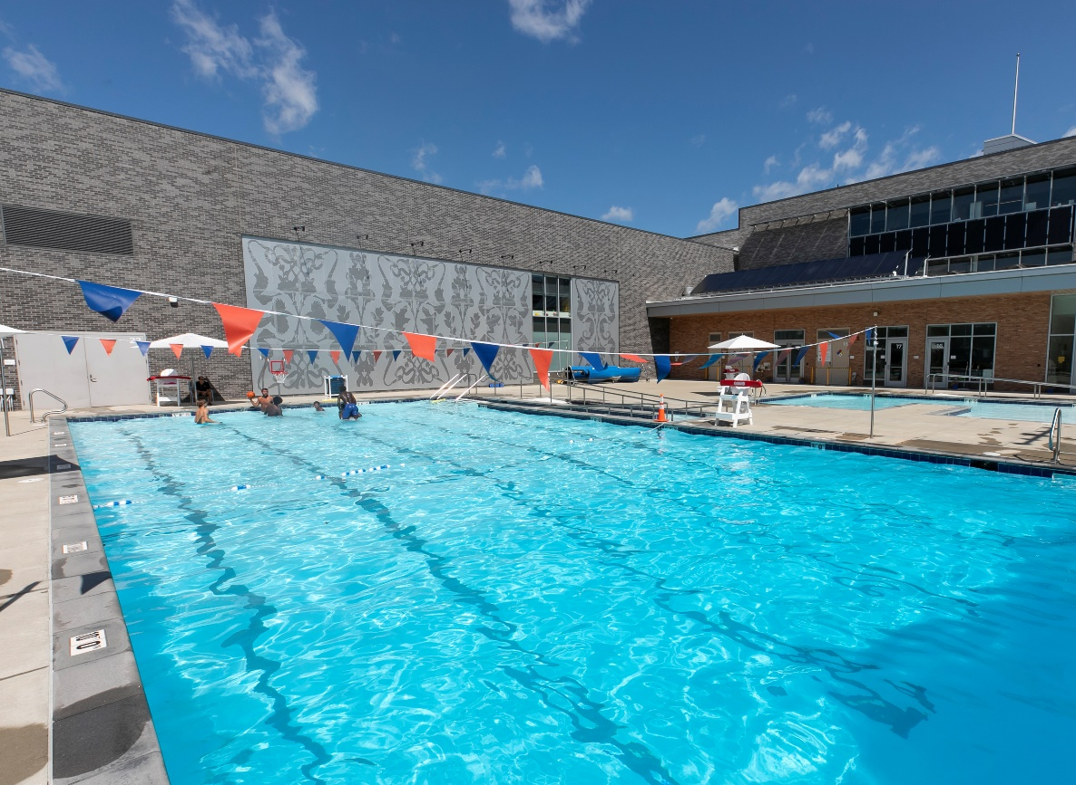

Sunday, June 22
🌡️ A series of 90°+ days is coming to Cambridge — time to cool off!
💦 Explore FREE waterplay features in parks across the city this summer.
Use the interactive map to find one near you ⬇️
🔗 camb.ma/4biqLYb
🔗 camb.ma/4n6Snqf
#CoolSafeCambridge #CambMA



Monday, June 23
🌡️ With a series of 90°+ days ahead, the City of Cambridge reminds you: Sun protection is essential!
☀️ UV rays cause skin damage and cancer—even on cloudy days
🧴 Use broad spectrum SPF 15
😎 Wear hats & sunglasses
☂️ Seek shade
#CoolSafeCambridge #CambMA #SummerInCambridge

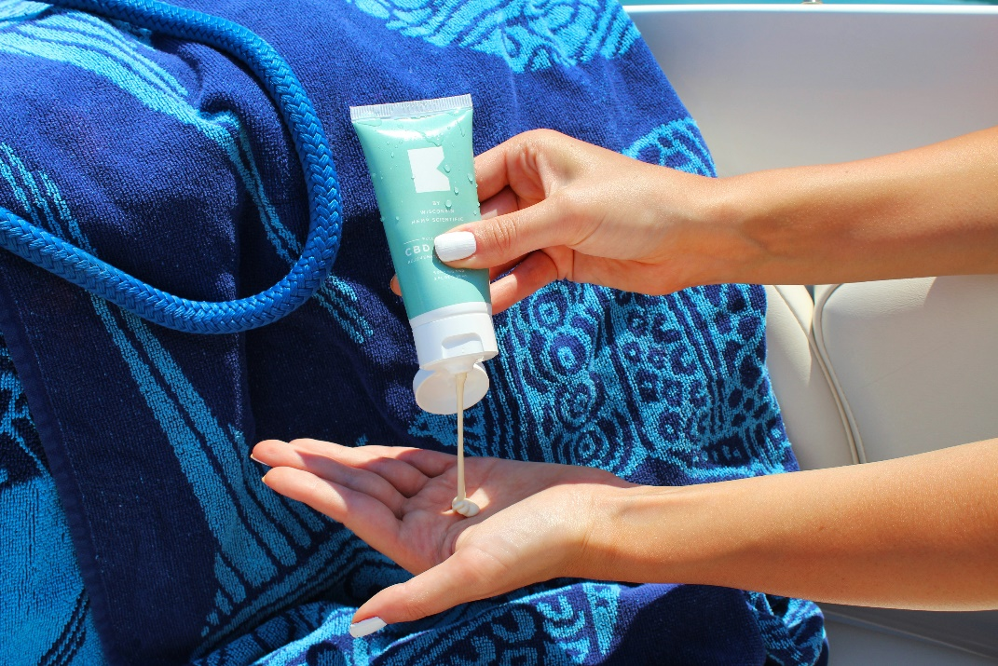

Tuesday, June 24
With 90°+ days ahead, pet safety is a HOT issue!
🚫 Never leave pets in parked cars
🐾 7-second rule: If the ground’s too hot for your hand, it’s too hot for paws
🏠 Leave pets safely at home during hot weather
🔗 camb.ma/4n6Snqf
#CoolSafeCambridge #CambMA



Wednesday, June 25
🌡️ With 90°+ days ahead, extreme heat can disrupt your business operations.
🏢 Make sure your building is ready by checking risks and your team protected.
Get tips + the business heat checklist: camb.ma/4kNgSr1
🔗 camb.ma/4n6Snqf
#CoolSafeCambridge #CambMA

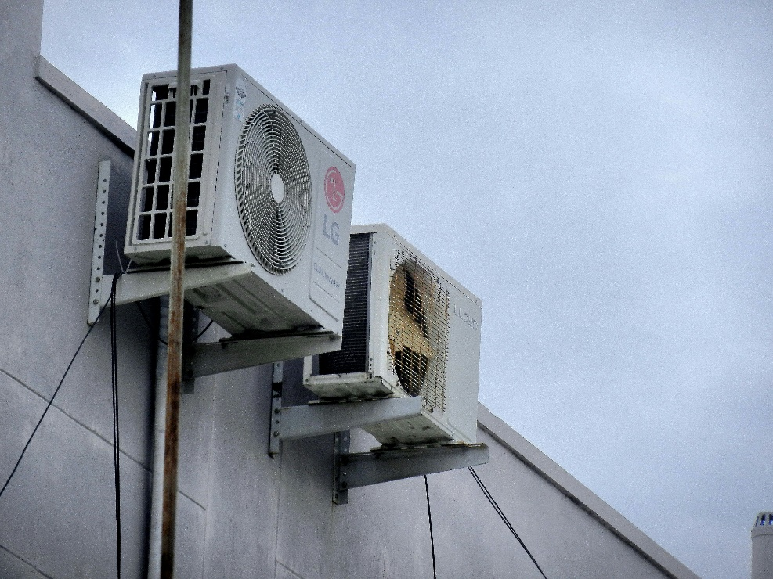

Threads
Saturday, June 21
🔥 A stretch of 90°+ days is coming to Cambridge!
🏊‍♀️ The War Memorial Recreation Center has indoor pools open year-round.
☀️ Gold Star Pool opens soon for outdoor swimming all summer long!
✅ Both are ADA-compliant and staffed by certified lifeguards.
👨‍👩‍👧‍👦 Great for families, lap swimmers, and local summer camps.
Find swim schedules, safety tips, and more at:
🔗 cambridgema.gov/susta...
CoolSafeCambridge #CambMA

Sunday, June 22
🌡️ A stretch of 90°+ days is headed to Cambridge — stay safe and cool this summer!
💦 Did you know Cambridge has FREE waterplay features in parks all across the city? Splash pads, sprays, and more!
📍Find one near you with this interactive map:
🔗 camb.ma/4biqL...
For more information about heat safety: camb.ma/4n6Sn...
CoolSafeCambridge #CambMA #Waterplay #SummerInCambridge

Monday, June 23
🌡️ A stretch of 90°+ days is coming to Cambridge — remember, sun protection isn’t just for summer days at the beach!
☀️ UV rays can damage your skin and cause cancer, even when it’s cloudy.
🧴 Always use broad spectrum SPF 15 or higher.
😎 Wear hats and sunglasses to protect your face and eyes.
☂️ Seek shade when you can to stay cool and safe.
CoolSafeCambridge #CambMA #SummerInCambridge

Tuesday, June 24
🌡️ A stretch of 90°+ days is coming to Cambridge — pet safety is a HOT topic!
🚫 Never leave your furry friends in parked cars, even with windows cracked. It gets dangerously hot FAST.
🐾 Remember the 7-second rule: if it’s too hot for your hand, it’s too hot for their paws.
🏠 Keep pets safe and cool by leaving them at home when it’s scorching outside. They’ll thank you!
For more Information: camb.ma/4n6Sn...
CoolSafeCambridge #PetSafety #CambMA

Wednesday, June 25
🌡️ 90°+ days are hitting Cambridge — is your business ready for extreme heat?
High temps can impact staff, equipment, and your ability to stay open.
✅ Prep your building
✅ Protect your employees
✅ Keep operations running
📋 Get the City’s heat-readiness checklist + tips for staying resilient: camb.ma/3SXZ1...
More info on heat safety: camb.ma/4n6Sn...
CoolSafeCambridge #CambMA #BusinessResilience #HeatSafety

Facebook
Sunday, June 22
🌞 Cambridge, are you ready for the heat? With a series of 90°+ days in the forecast, the City of Cambridge wants to make sure everyone—residents, families, pet owners, and businesses—stays safe, cool, and prepared. Here's your all-in-one guide ⬇️
💦 Cool Off at a Cambridge Pool
Whether you’re looking for a place to swim laps or bring the family, we’ve got options!
🏊 War Memorial Recreation Center (1640 Cambridge St.) offers three indoor pools year-round, including lap lanes, a diving tank, and a circular pool.
☀️ Gold Star Pool (123 Berkshire St.) opens for outdoor swim late June through Labor Day—free to Cambridge residents!
Learn more and view pool schedules:
🔗 https://www.cambridgema.gov/sustainable/coolsafecambridge
🌊 Find Waterplay Features Near You
Splash pads and spray features are free and open to the public during the summer months!
Use the interactive map to explore waterplay locations in your neighborhood and beyond:
🔗 https://www.cambridgema.gov/cdd/parks/waterplaymap
☀️ Protect Your Skin All Summer Long
Sun safety isn’t just for the beach—UV rays can damage skin even on cloudy days.
🧴 Use broad spectrum sunscreen SPF 15+
😎 Wear hats and sunglasses
☂️ Seek shade when possible
👶 For babies under 6 months, avoid sunscreen—use shade and hats instead
💡 Early detection saves lives. Check your skin regularly for new or changing spots.
More sun safety tips:
🔗 https://www.cambridgema.gov/sustainable/coolsafecambridge
🐶 Heat Safety for Pets
Hot weather can be dangerous for animals.
🚫 Never leave pets in parked cars, even with windows cracked
🐾 Use the 7-second rule: if it’s too hot for your hand, it’s too hot for their paws
🏠 When in doubt, leave your pets safely at home
🏢 Business Owners: Prepare for Extreme Heat
High temps can impact your building, your employees, and your bottom line.
Is your business prepared?
✅ Check cooling systems and indoor temps
✅ Provide water and extra breaks for staff
✅ Protect sensitive inventory (like food or meds)
✅ Sign up for emergency alerts: www.cambridgema.gov/subscribe
💼 Use the City’s business heat-readiness checklist:
🔗 https://www.cambridgema.gov/CDD/econdev/smallbusinessassi...
🏙️ Let’s keep Cambridge cool, safe, and resilient together.
For all heat safety resources and cooling options, visit:
🔗 https://www.cambridgema.gov/sustainable/coolsafecambridge
#CoolSafeCambridge #CambMA #HeatSafety #SummerInCambridge #PetSafety #SunSafety #BusinessResilience

